Lab Exercise 20
Creating a Pipeline Script

Objective: To create a pipeline script for automating build processes in Jenkins

Tools required: Jenkins

Prerequisites: None

Steps to be followed:
- Log in to the Jenkins CI tool and create a pipeline script

Step 1: Log in to the Jenkins Cl tool and create a pipeline script

- Open the browser, go to the Jenkins Dashboard by typing localhost:8080 in your browser, provide the credentials, and click the Sign in button


Note: The credentials for accessing Jenkins in the lab are Username: admin and Password: admin.

- Click on the New Item option as shown in the screenshot below:

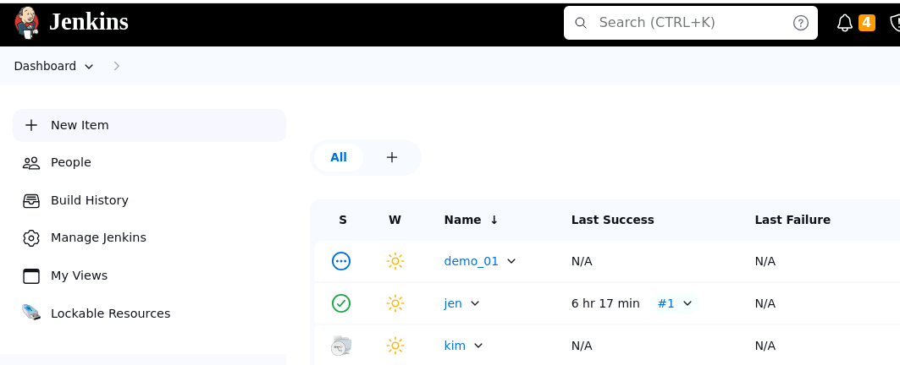

- Enter a desired name for the project, select Pipeline, and then click on OK as shown in the screenshot below:

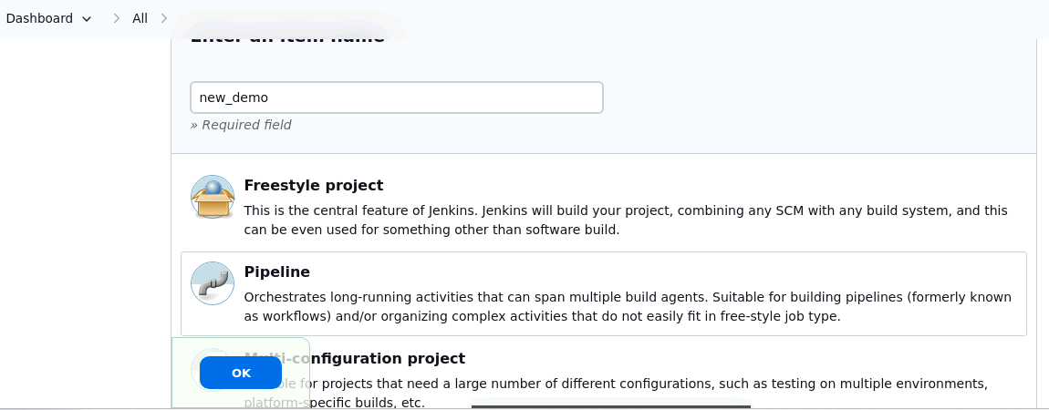

- Click on Pipeline as shown in the screenshot below:

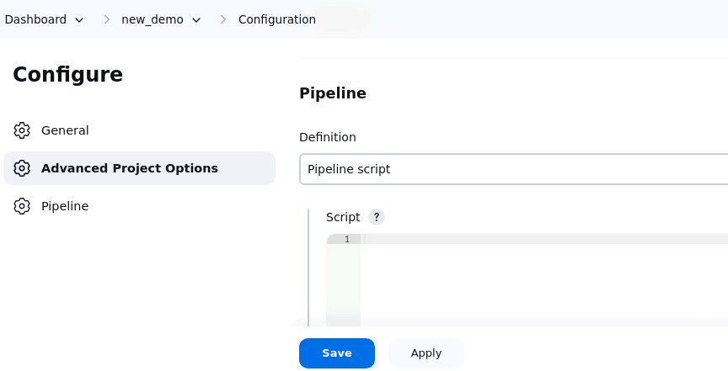

- Enter the following pipeline script in the script editor and click on Save as shown in the screenshot below:
pipeline {
agent any
stages {
stage("hello") {
steps{
echo"welcome to Jenkins pipeline"
}
}
}
}

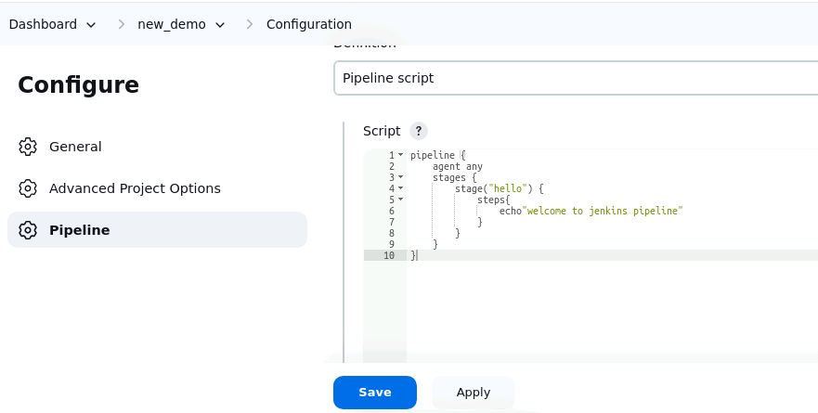

Output:-

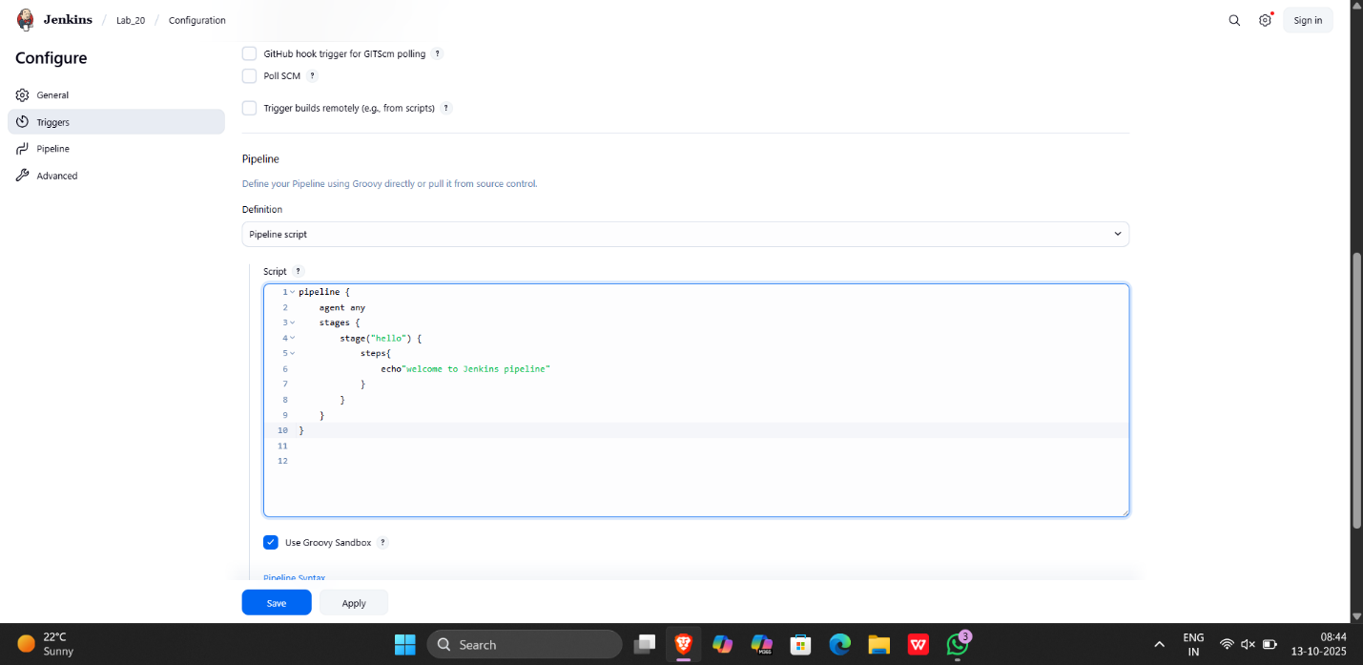

- Click on Build Now to run the pipeline script as shown in the screenshot below:

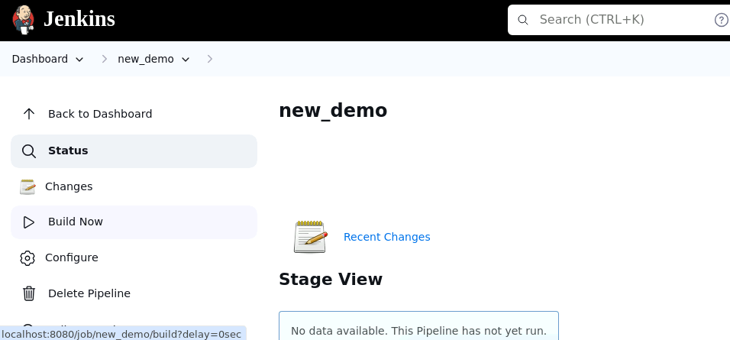

- Hover over the milliseconds number next to the build stage name as shown in the screenshot below:

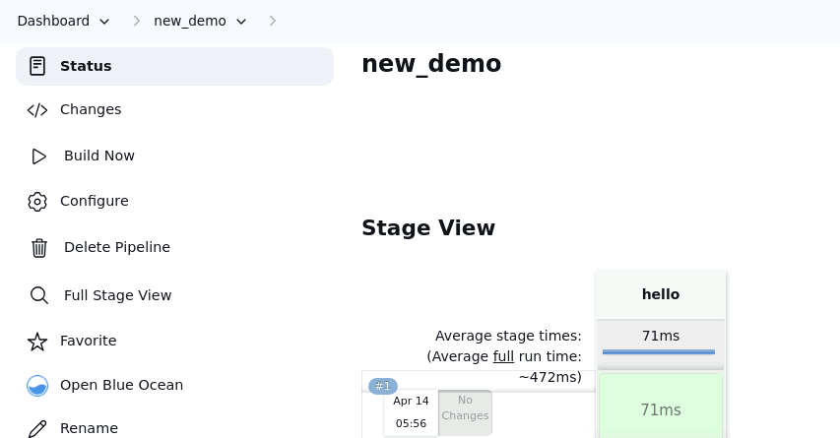

Note: Ensure that you hover the cursor over the milliseconds number without clicking on it

- Click on Logs as shown in the screenshot below:

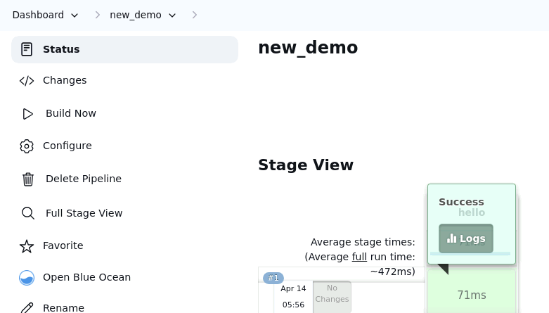
Check for the message in the top-left corner to confirm the successful execution of the pipeline stage as shown in the screenshot below:

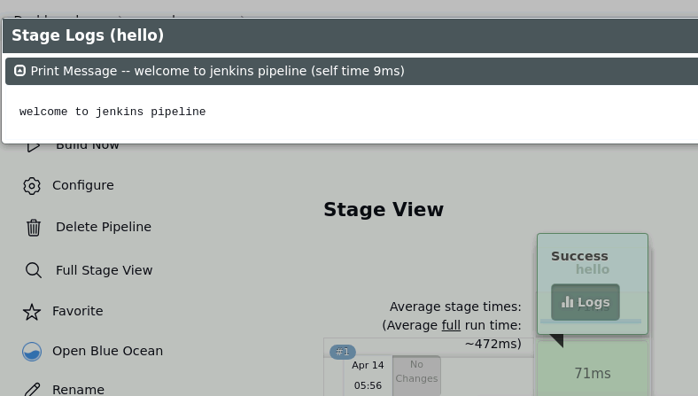

By following these steps, you have successfully created a pipeline script for automating build processes in Jenkins.

Output:-

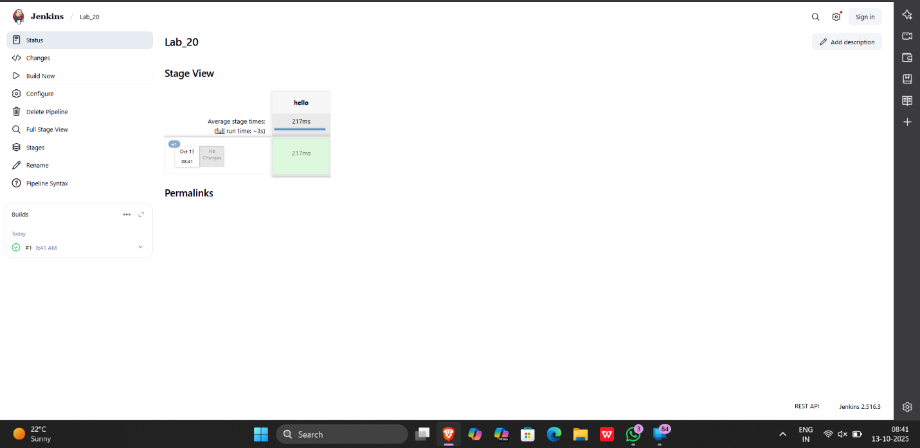

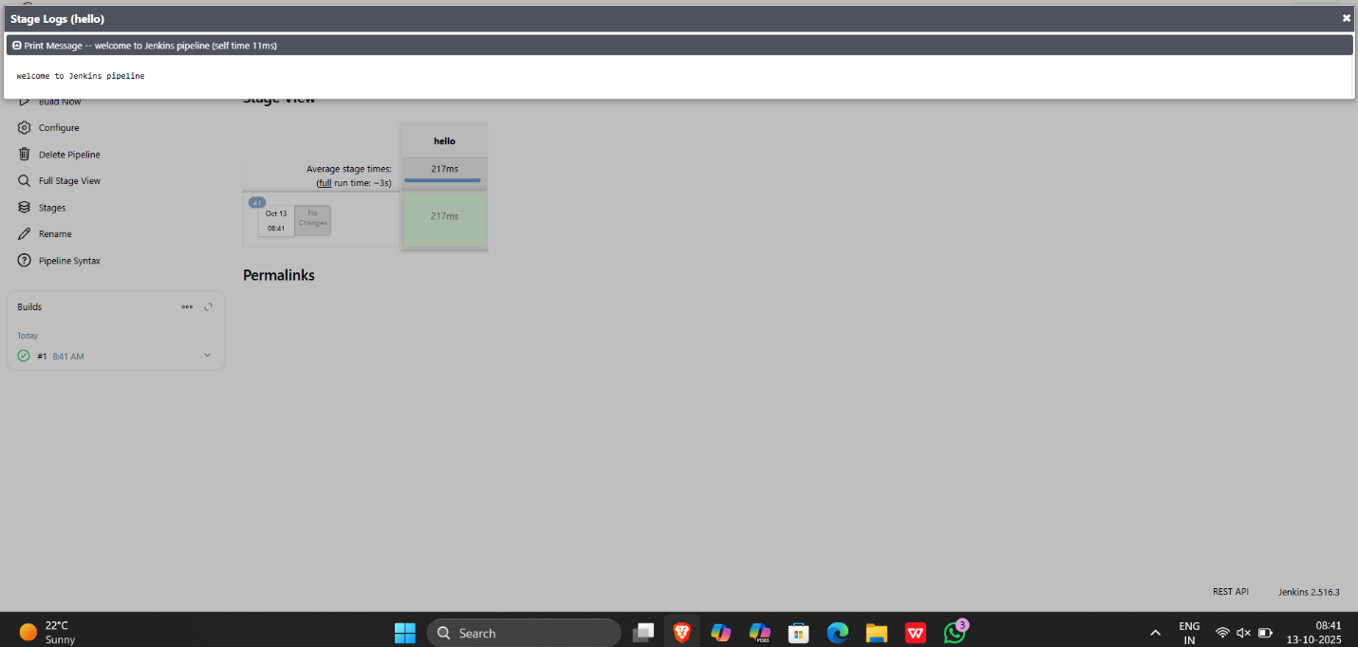

Creating a pipeline for a project

1) Create a built using pipeline

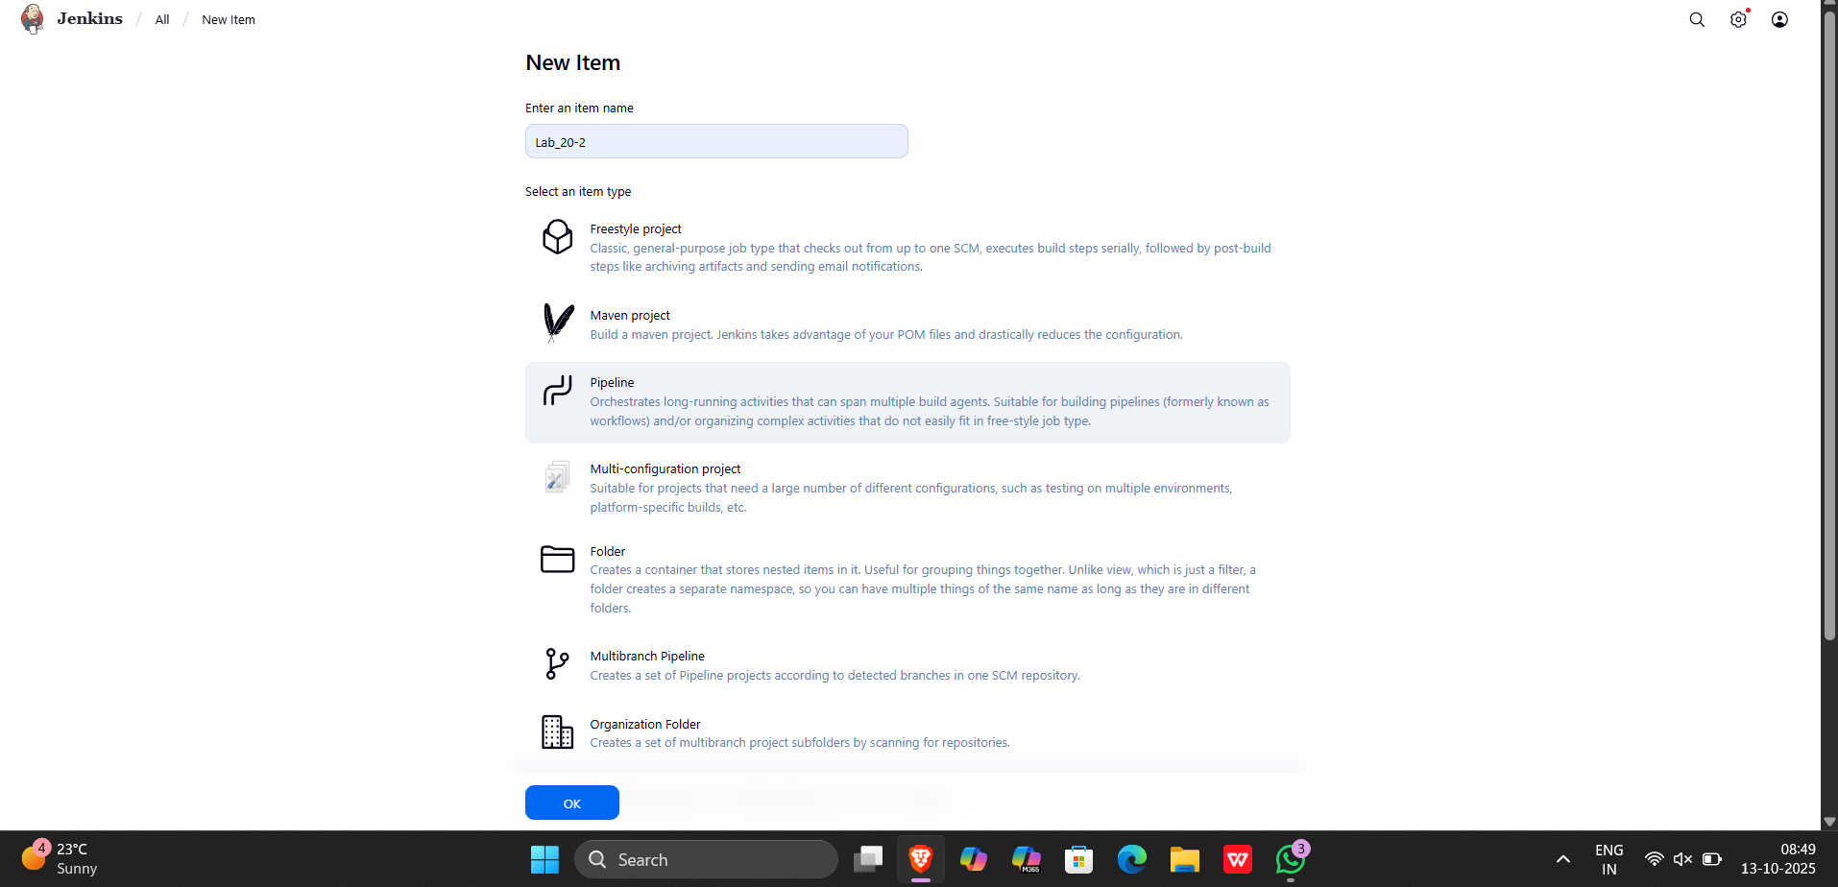

2) write the script for the pipeline in jenkinsfile in github

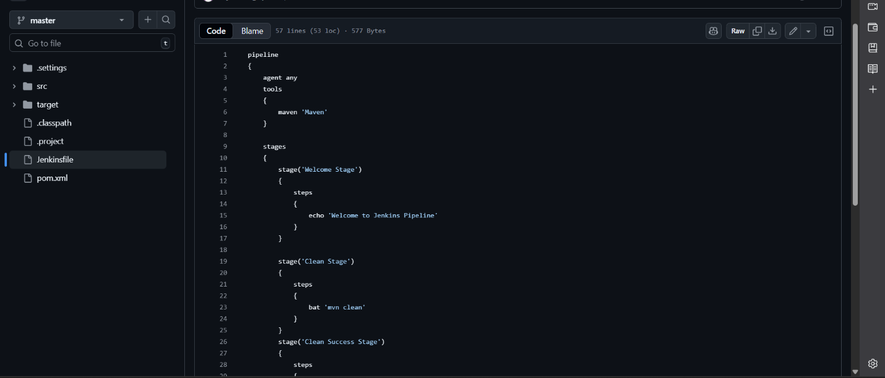

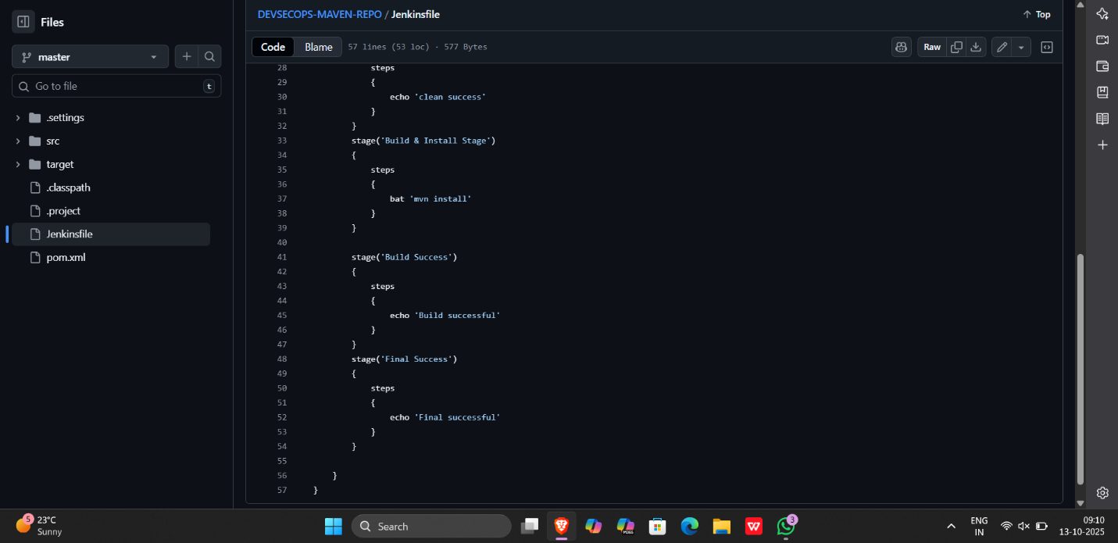

3) Add the repository url in github project and in pipeline

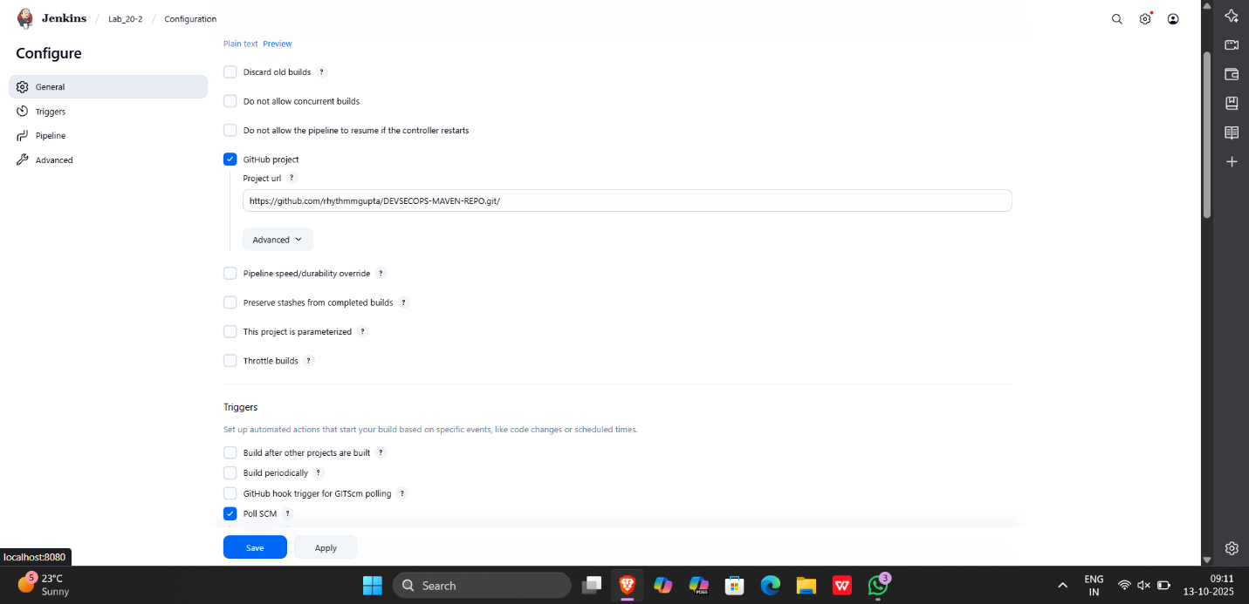

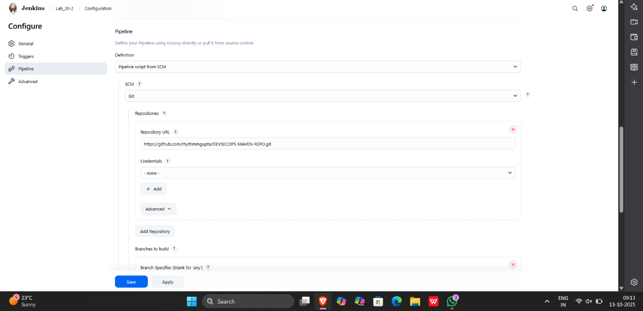

4) check poll scm option

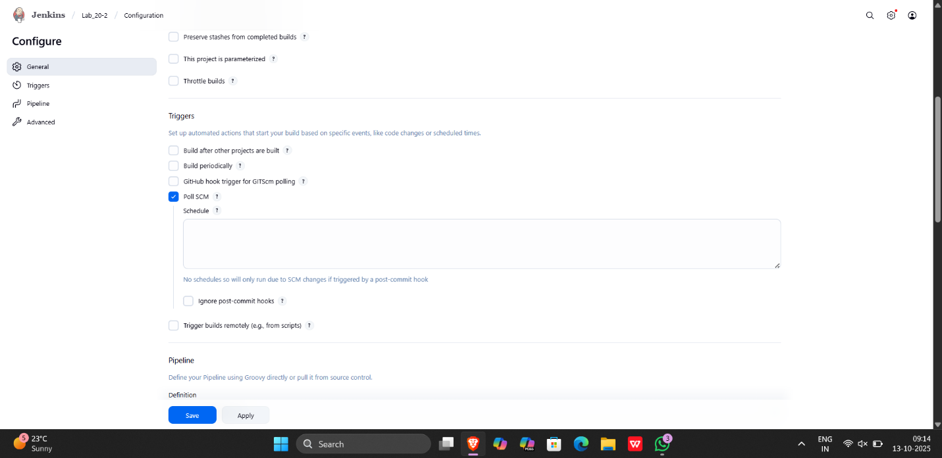

Output:-

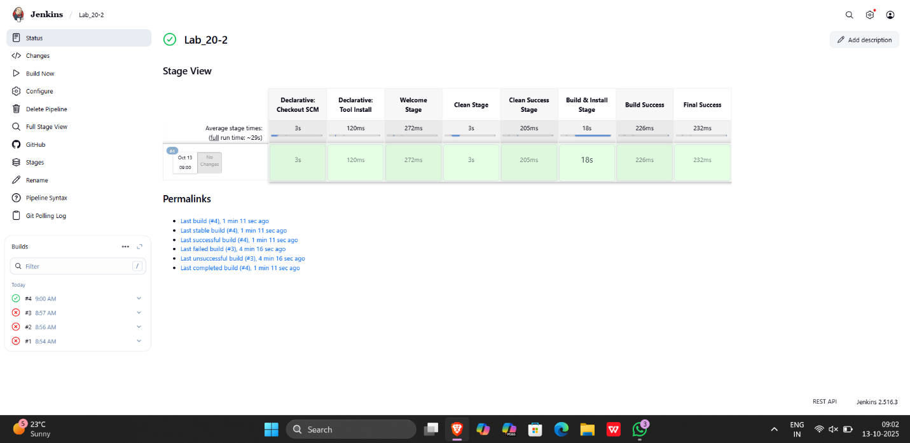

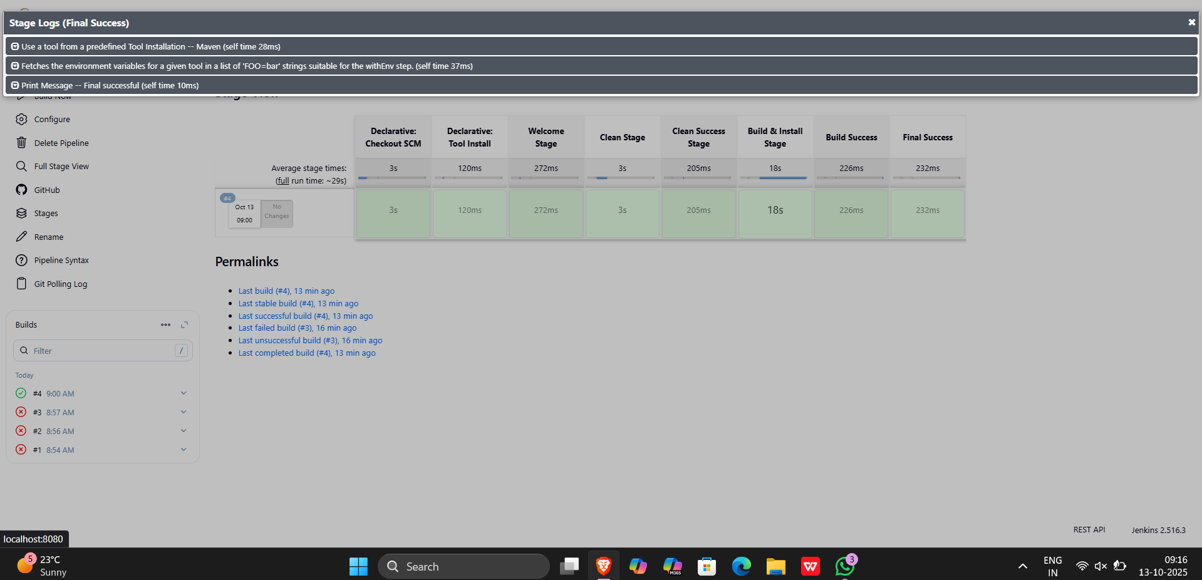

Pipeline script

pipeline
{
agent any
tools
{
maven 'Maven'
}

stages
{
stage('Welcome Stage')
{
steps
{
echo 'Welcome to Jenkins Pipeline'
}
}

stage('Clean Stage')
{
steps
{
bat 'mvn clean'
}
}
stage('Clean Success Stage')
{
steps
{
echo 'clean success'
}
}
stage('Build & Install Stage')
{
steps
{
bat 'mvn install'
}
}

stage('Build Success')
{
steps
{
echo 'Build successful'
}
}
stage('Final Success')
{
steps
{
echo 'Final successful'
}
}

}
}

